# CS 255 System Design Document Template

By Joseph Wilfong

## UML Diagrams

### UML Use Case Diagram

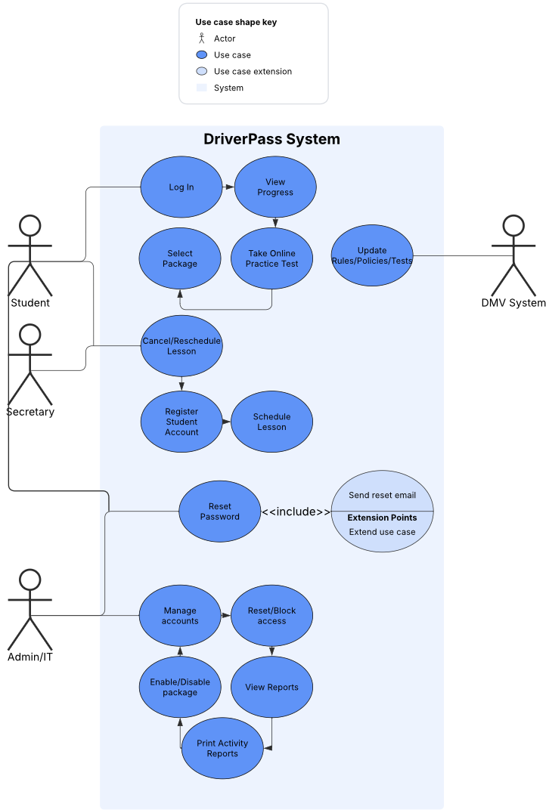

### UML Activity Diagrams

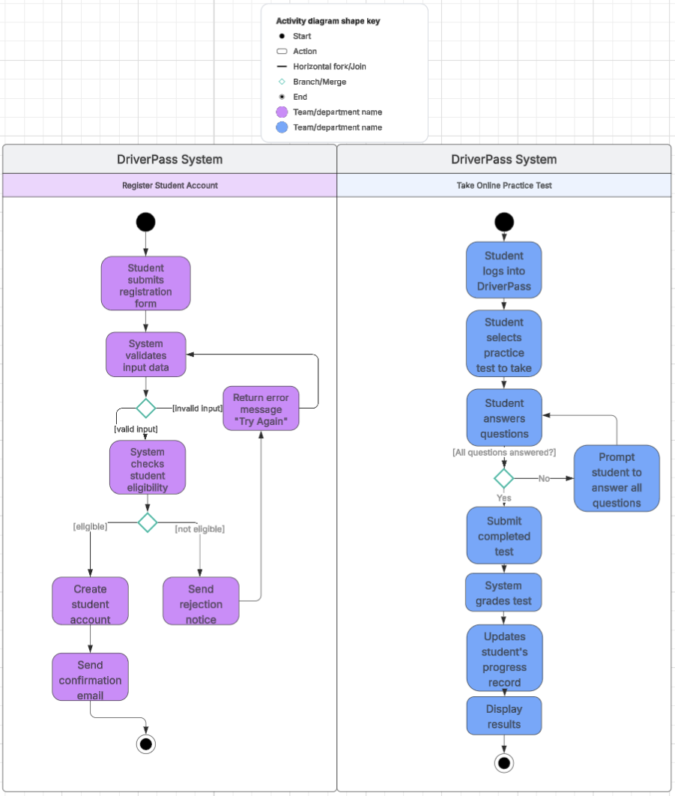

### UML Sequence Diagram

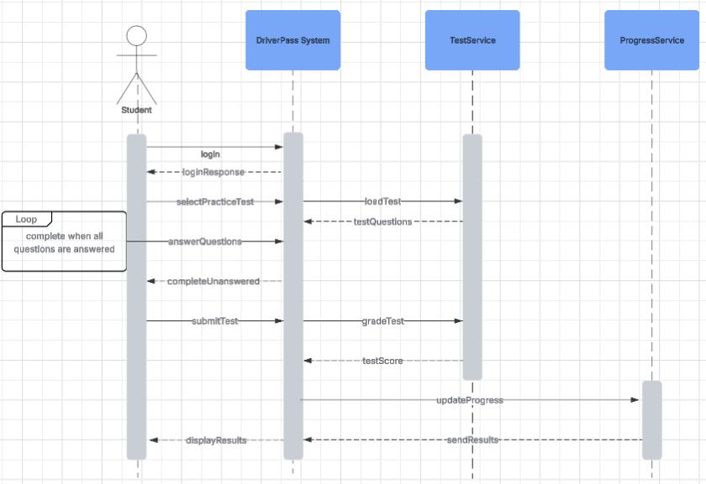

### UML Class Diagram

## 

## Technical Requirements

The DriverPass system requires reliable user devices such as desktops, laptops, tablets, or smartphones with internet access to run its web-based application via modern browsers. The backend must be hosted on secure and scalable cloud infrastructure that supports a relational database for storing user accounts, tests, progress records, and system logs. The software stack should include robust web frameworks and programming languages compatible with cross-platform deployment and responsive design. Essential tools include UML modeling software for design, version control systems for code management, and automated testing frameworks to ensure quality. Infrastructure must provide high availability, automatic backups, secure data transmission with encryption, and monitoring system performance and security events.